Test Information
Test Name (as it will be reported to the Customer):  (50 character maximum) |  |  | Filler | Legacy Test Code
Test Name (as seen by analyst in STARLIMS ):  (50 character maximum) |  |  | Filler
Test Library (Home):
Test Type (Default (non-culture), Micro (culture)):
Team Name:
Team Supervisor, Subject Matter Expert(s):
Specimen Category (Human, Animal, Food, Water):
Specimen Type, for Panel Identification in Accession Number:
Note(s):
References:
Where Used: |  |  |  |  |  | Test Performed in
# | Panel Name (50 character maximum) | Test Library | Accessioning Number-Letter Designation: | Test Case | Panel Order Code | Nashville | Knoxville | Memphis-Shelby County
1
2

Equipment (from Static table) – Test Name
# | Equipment Name ID (20) | Equipment Type  (60 Character Max) | Manufacturer  (50 Char Max) | Model  (15 Char Max) | Serial Number (50 Char Max) | Interface (Manual, File, Fusion, Serial) | Used for this test | Notes
1
2
3
4

Quality Controls (QCs) used in this Assay – Test Name

# | QC Name  (20 Char. Max)  (The name you want to see in STARLIMS for this QC) | Micro Component  Type | Micro Component | Frequency  (By Run: Mandatory; By Lot: Optional) | Expected Response (leave empty if multiple possible values) | Added by default? | Organism | Strain# | Material | Quantity | Units
1
2
3
4
5
6
7
8
9
10

Materials/Reagents - Test Name
# | Material Code  (30 Char Maximum) | Material Name (100 Char Maximum) | Material Type  (15 Char Maximum) | Unit of Measure (15 char) | Micro Component  Type | Micro Component | Add by Default | Manufacturer/Supplier (15 Char Maximum)
1
2
3
4
5
6
7
8
9
10
12
13
14
15
16
17

MicroComponents - Test Name
# | Micro Component  Type | Micro Component ID | Micro Component Name | Reportable | Report Interpretation | Added by Default when Sample is created | Comments
1
2
3
4
5
6
7
8
9
10

Micro Panels - Test Name

Analyte(s) - Test Name

 | LOINC Code | Analyte  (maximum number of characters=50) | Reported Analyte Name if different
1
2

Multiple LOINCs for Analyte Above - Test Name
 | LOINC Code | Analyte  (maximum number of characters=50) | Reported Analyte Name if different
1
2
3
4
5
6
7

Possible Results – Test Name

Possible Results for Test
# | Analyte | Result | SNOMED Code | LOINC# | Status  (OOS, Done) | As appears on Final Report  (absence of text in this column indicates that the analyte’s results do not appear on the Final Report)
1
2
3
4
5
6
7
8
9
10
11
12
13
14
15
16
17
18

Canned Comments - Test Name
Common comments for this test.
# | Associated Comments Code  (max 15 characters) | Comments for Preliminary and Final Reports:  •Folder/Panel, Accession/Sample, Test, Step, Run, or Result.  •Triggered Manually, by Qualifiers, or by Calculation (1500 max) | F/P | A/S | Tst | Stp | Run | Res | Triggered by
 |  |  |  |  |  |  |  |  | Automatic | Manual | Qualifying  Condition | Calc
1
2
3
4
5
6

Sample Container Labels - Test Name
Label | For Each Sample |  |  | Description | Applicable
Label | Number of Labels |  |  | Description | Yes | No
Label | Configured | Printed | Placed on Hold | Description | Yes | No
Standard Clinical Label | Yes | 1 | none | Standard Clinical Labels should be configured for each Sample | X
Standard Freezer Label | Yes | 0 | 1 | Freezer Labels should be configured for this Panel | X
Standard Clinical Sendout Label | Yes | 0 | 1 | Sendout Labels should be configured for this Panel | X
The above labels are printed if this test is accessioned and performed as a standalone test in its own Panel |  |  |  |  | X
This test is only run as a reflex test from a previous testing step. Labels were affixed to sample container in the previous step. |  |  |  |  |  | X
This test may have been reflexed from a previous testing step wherein labels were affixed to sample container, thus requiring no additional labels. |  |  |  |  |  | X
This test is accessioned in XXXX Panel and is run simultaneously with YYYY. Labels were affixed to sample container at accessioning.

Notes:
- Standard Clinical Labels are automatically printed at accessioning.
- Standard Freezer Labels are configured, placed on hold, and printed “on demand” as needed by the laboratorian
- Sendout Labels are configured, placed on hold, and printed “on demand” as needed by the laboratorian
- Label process used in Version 9 is also to be used in Version 11

- Alerts- Test Name
Display an Alert if:
 | Condition | Initiation | Action | Recipient | Applicable to  this Assay
 |  |  |  |  | Yes | No
1 | Run QC: reported as Fail or Invalid | Appears in bench lab, Pass the Run –Yes or No? | Laboratorian selects Yes or No |  | X
2 | Sample QC: Internal Control reported as Fail or Invalid | Appears in bench lab | user decides whether to retest |  |  | X
3 | Result =“Retest” (full retest, all analytes retested) | Appears in bench lab | user dismisses or executes |  |  | X
4 | Result =“DETECTED” | Appears in bench lab | user decides whether to retest |  |  | X
5 | Result =“POSITIVE” | Appears in bench lab | user decides whether to retest |  |  | X
6 | Result =“Presumptive Positive” | Appears in bench lab | user decides whether to retest |  |  | X
7 | Result =“Indeterminate” | Appears in bench lab | user decides whether to retest |  |  | X
8 | Result =“Inconclusive” | Appears in bench lab | user decides whether to retest |  |  | X
9 | Result =“Equivocal” | Appears in bench lab | user decides whether to retest |  |  | X
10 | Result=”Fail” | Appears in bench lab | user decides whether to retest |  |  | X
11 | Result = Sequence not confirmed | Appears in bench lab | user dismisses or executes |  |  | X
12 | Result = Inhibitory Potential | Appears in bench lab | user dismisses or executes |  |  | X
13 | Result = Equipment error/failure |  |  |  |  | X
14 | Result = Test Not Performed |  |  |  |  | X
15 | Result = Unsatisfactory for Testing |  |  |  |  | X
16 | Result = Not Detected |  |  |  |  | X
- Communications Log - Test Name
Make written entry in Communications Log if:
 | Condition | Verbal report also, to | Time Frame | Applicable to  this Assay
 |  |  |  | Yes | No
1 | Result =“POSITIVE” | Notify CDC Helpdesk via email and request shipment instructions |  |  | X
2 | Result = “Equivocal” or “Presumptive positive” | Must be reported to TN SHOC |  |  | X
- Reflex Tests- Test Name

Reflexed from:
Reflexed From | Order Code | Condition |  | Applicable to  this Assay
 |  |  |  | Yes | No

Reflexes to:
Certain results could reflex to other tests (see table in Triggers section).
 | Reflexed to | Order Code | Condition |  | Applicable to  this Assay
 |  |  |  |  | Yes | No
1 | Reflexed to anywhere |  |  |  |  | X  (default)
2
3

- Triggers- Test Name
Certain results indicate a potential Reflex to another test: see table below. Triggers display alert box and user chooses to execute or dismiss the execution (i.e., the execution is manually chosen). For some, a certain result triggers a culture - a combination of analyte name and result triggers to the next step.
 | Target Pathogen | Result | Triggers |  | Applicable to this Assay
 |  |  |  |  | Yes | No
1 | Run QC | Reported as Fail or Invalid | Retest all samples in run |  | Requestor decides
2 | Sample QC (Internal Control) | Reported as Fail or Invalid | Retest individual sample |  |  | X
3a | Result =“Retest” (full retest, all analytes retested) |  | Retest all samples in run | After first re-run, lab decides whether to execute trigger or dismiss | Requestor decides
3b | Result =“Retest” (partial retest) |  | Retest only samples in question, not necessarily all samples in the test. All analytes for the retested sample are included in the retest. | After first re-run, lab decides whether to execute trigger or dismiss |  | X
4 | Result =DETECTED |  |  |  |  | X
5 | Result =Susceptible |  |  |  |  | X
6 | Result =Indeterminate | e.g., Ct value 37-39.9 | Retest samples. Laboratorian will execute or dismiss trigger. |  |  | X
7 | Result =Resistant |  |  |  |  | X
8a | Result = Sequence not confirmed |  | Retest only samples in question, not necessarily all samples in the run. |  |  | X
8b | Result = Sequence not confirmed |  | Retest alL SAMPLES in the run. |  |  | X
9 | Result = Inhibitory Potential |  |  |  |  | X
10 | Result = Equipment error/failure |  |  |  |  | X
11 | Result = Test Not Performed |  |  |  |  | X
12 | Result = Unsatisfactory for Testing |  |  |  |  | X
13 | Result = Not Detected |  |  |  |  | X
14 | Result=Negative |  | Report to CDC via LRN-RM |  |  | X
15 | Result=Equivocal |  | Report to CDC via LRN-RM and send the specimen to CDC for confirmatory testing. |  |  | X
16 | Result=Presumptive positive |  | - Notify TN SHOC  - Report to CDC via LRN-RM and send the specimen to CDC for confirmatory testing |  |  | X

- Outsourcing- Test Name
 | Condition | Description | Process | Applicable to  this Assay
 |  |  |  | Yes | No
1 | Outsourced to a non-TN Lab | Outsourced to CDC, Quest, LabCorp or other lab. | Decided either immediately after accessioning; or after tested internally, then sent to CDC or Quest or LabCorp. When results received, record their results as a different test (indicating who actually did the test) and attach the results. See PH11 User Manual –Shipping and Receiving Outsource Samples. | Unlikely
2 | Site-to-site Transfer to another TN lab-routine | Test is transferred to another TN laboratory if initial test results require reflexing to a test not performed in initial TN lab but performed in another TN lab. | See PH11 User Manual – Site to site Transfer: A site to site transfer of containers/aliquots can be performed using the Site Transfer button in the Containers Management module. Performing a site transfer is useful when you wish to move aliquots/samples to another site for testing, and then transfer back to the original site for approval or re-testing. |  | No
3 | Site-to-site Transfer from another TN lab-routine | Test is transferred from the performing laboratory back to the initial laboratory. | See PH11 User Manual – Site to site Transfer: A site to site transfer of containers/aliquots can be performed using the Site Transfer button in the Containers Management module. Performing a site transfer is useful when you wish to move aliquots/samples to another site for testing, and then transfer back to the original site for approval or re-testing. |  | No
4 | Site-to-site Transfer to another TN lab-exceptional | Although unlikely, the test could be transferred to another TN laboratory in the event of a surge or inoperable instrument. | See PH11 User Manual – Site to site Transfer: A site to site transfer of containers/aliquots can be performed using the Site Transfer button in the Containers Management module. Performing a site transfer is useful when you wish to move aliquots/samples to another site for testing, and then transfer back to the original site for approval or re-testing. |  | No

- Test Logic Description/Diagram- Test Name
Indicate any logic or action taken on results, such as:
- For Micro/Culture Assays, draw diagram
- Assay Particulars:
 | Condition | Action |  | Applicable to this Assay
 |  |  |  | Yes | No
1 | Approval of Results | Requires Manual approval (instead of automatic) | “Run Approval” is done prior to Final Conclusion approval | X (default)
2 | Samples run in duplicates |  |  |  | X
3 | Samples must be re-run in duplicates |  |  |  | X
4 | Positives create a reflex test | See “Triggers” section (above) |  |  | X
5 | Approval of Reflex Test | Requires Manual approval (instead of automatic) | Not applicable |  | X

- Instrument Interface - Test Name
 | Used in this Assay
Interface Type | Nashville | Knoxville | Memphis-Shelby County
Manual
File
FUSION
Serial RS-232
Not Applicable to this test | X

- External Interface
  - HL7 ETOR PTBMIS Results Message

 | Condition | Action | Comments | Applicable
 |  |  |  | Yes | No
 | Overarching Rule: If a result is reported on Final Report, it is reported via HL7.
1 | Reportable | Map to HL7 Results Message |  | X
2 | Reportable if this test is accessioned and performed in its own standalone Panel | Map to HL7 Results Message | If it can be ordered separately, it is reported.
3 | Reportable if this Test is Reflexed from another Test | Map to HL7 Results Message and indicate in Results Message the Parent Test of which this is a Child. The Parent itself could be a Child, in which case this would be a grandchild. | STARLIMS HL7 ETOR must link the Parent/Child Relationships in the outbound HL7 Results Messages
4 | Not Reportable | Do not map to HL7 Results Message
5 | Not Reportable if this this test is reflexed from a Micro Tree and is part of a final interpretation of the microbiological testing results | Do not map to HL7 Results Message
6 | Not Reportable, part of a final interpretation of the microbiological testing results | Do not map to HL7 Results Message | Some non-standalone tests are sometimes reported and sometimes not

  - External Interface for this Test
External Interface Programs | Direction | Used for this Test | Method/Format
ETOR Submitters (PTBMIS, vxVistA, Emdeon) HL7 v2.5.1 | Inbound | Yes | HL7 Test Orders
ETOR with PTBMIS (Health Department Public Health application) | Outbound | Yes | HL7 Results Message
ETOR with vxVistA ( for TN’s EPI-Electronic Public Health Information) – PTBMIS replacement system, first clinic/site implementation 6/30/2015 | Outbound | Yes, when vxVistA becomes available | HL7 Results Message
ETOR with KKR/Change Healthcare (Knoxville/Knox County Region HL7 vendor) | Outbound | Under development, to do for V11 | HL7 Results Message
ELR with CEDEP Surveillance Applications | Outbound | Not in production on V9, need for V11 | HL7 Results Message
ELR with PHLIP (CDC Influenza, v2.3.1 to v2.5.1) | Outbound | Not applicable | HL7 Results Message
Environmental Water Billing Extract for Edison | Outbound | Not applicable | Excel Worksheet
Influenza Extract for CEDEP (Epidemiology) | Outbound | Not applicable | Excel Worksheet
RightFax (not routinely used, used only when requested) | Outbound | Yes | .PDF
Report Distribution via U.S.P.S. (or optionally, HL7 in future) | Outbound | Yes | U.S.P.S.

  - External Interface Workflow
Source Output |  |  |  | Object Output |  |  | ETOR |  |  | ELR |  | Excel |  | fax | mail
Source Point | Source File Format | Message Type | Integration Engine for Transformation  (maps and routes Source File to Object File) | Object File Format | Recipient Point | Used for this Test Order/Result | PTBMIS | vxVistA | KKR | CEDEP | PHLIP | Edison | Influenza-CEDEP Epi | RightFax | U.S.P.S.
ETOR Submitters (PTBMIS, vxVistA, Emdeon) | Unknown | ETOR | Unknown | HL7 | STARLIMS PH11 | Yes, inbound test order | X | x | x
STARLIMS Test Result | XML File | ETOR | Rhapsody | HL7 | Submitters (& Others) | Yes, outbound test result | X | x | x
STARLIMS Test Result | XML File | ELR | Rhapsody | HL7 v2.5.1 | CEDEP (specific disease, not Flu now) to do | Yes, outbound test result
STARLIMS Test Result | XML File | ELR PHLIP | Rhapsody | HL7 v2.5.1 | CDC Influenza | Yes, outbound test result
STARLIMS Test Result | XML File | PHINMS | Rhapsody | HL7 v2.5.4 | CDC LRN-B | No
STARLIMS Test Result | Excel |  | - | Excel | CEDEP Epidemiology | Yes, outbound de-identified
STARLIMS Test Result | .PDF | RightFax | - | .PDF | Submitters | Yes, outbound test result |  |  |  |  |  |  |  | x
STARLIMS Test Result | Hardcopy | U.S.P.S. | - | Hardcopy | Submitters | Yes, outbound test result |  |  |  |  |  |  |  |  | X

Screens and Reports - Test Name

Accessioning Screens
Standard V11 Human Accessioning Screen (format as of 07/06/2015)
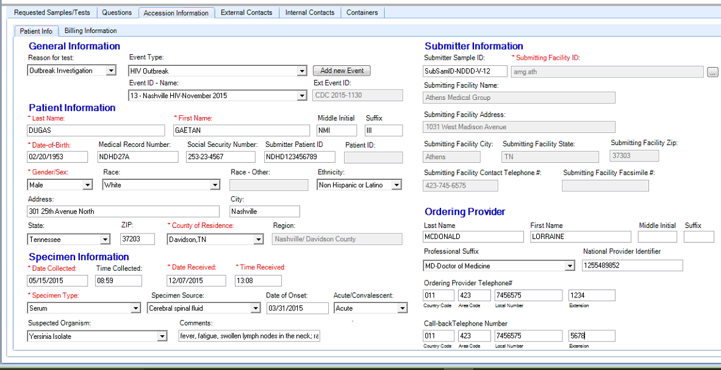

Specimen Container Labels
Standard Human Specimen Container Labels (formats as of dates indicated below)
Screenshot of Label | Description
V11 – Standard Label (not to scale)  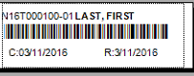 | Sample for: Standard Clinical Label - 7/01/15 V11  Test Library: Multiple  Bar Code Symbology: Code 39  Bar Code Label Dimensions: 2.25” x .75”  Truncate excess name off of right side of label (first name)  Indent from left-1/2 character for margin of error in alignment of form in printer  Label Printer Models: Zebra LP 2844z and Zebra GK 420t for barcode labels  Standard Clinical Labels can be printed for each Sample, or created and placed “on hold”. See options selected in Sample Container Labels Section.
V11 – Freezer label  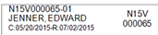 | Sample for: Freezer Label – 7/01/15 V11  Test Library: Multiple  Label Dimensions: 1.6” x .34”  Truncate excess name off of right side of label (first name)  Indent from left-1/2 character for margin of error in alignment of form in printer  Brady 1344 for freezer labels  The Brady label printer requires installation of Seagull Scientific drivers to handle the label format. http://www.seagullscientific.com/label-software/barcode-label-design-and-printing.aspx  Freezer Labels can be printed for each Sample, or created and placed “on hold”. See options selected in Sample Container Labels Section.
V9 – Freezer label (showing the physical size and shape)
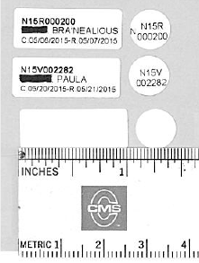
V11 – Sendout Container Label  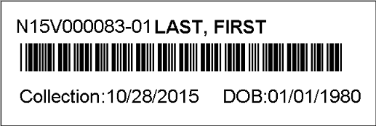 | Sample for: Sendout Label – 10/28/15  Same physical label as Standard Clinical Label.  Bottom line uses Patient Date-of-Birth instead of Received Date.  Sendout Labels can be printed for each Sample, or created and placed “on hold”. See options selected in Sample Container section.

Sample Worksheet – Need examples for Test Name
Standard Human Sample Worksheet

Before Results Entry
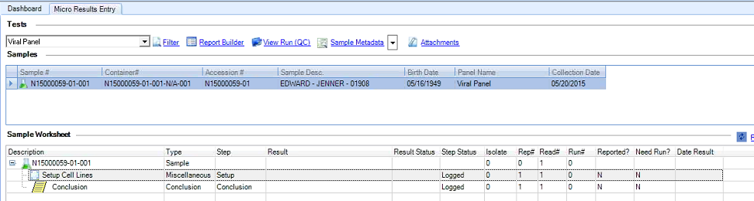

After Results Entry
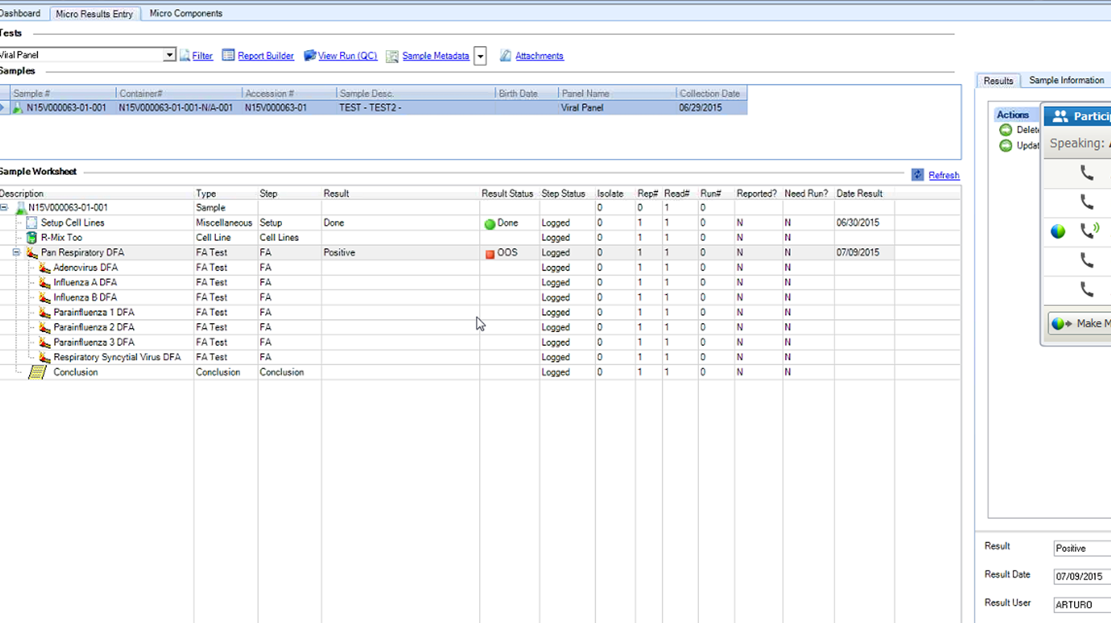

Standard TN Outsource/Sendout Manifest
(Need Example for Test Name)

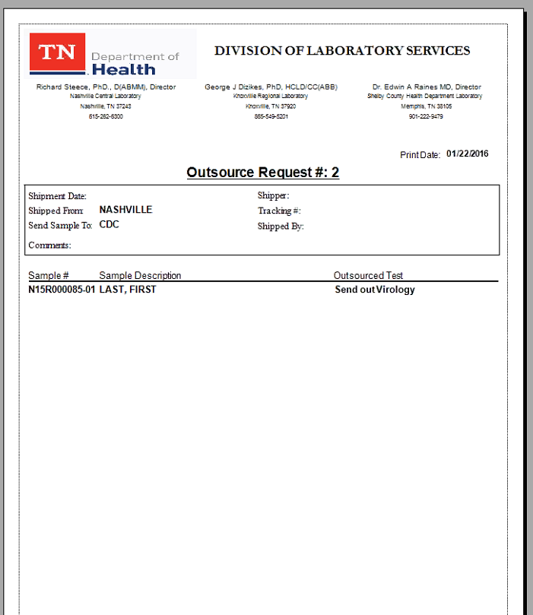

Preliminary/Final Report (Human) - Serology (6/2/15)
Standard heading for all human Final Reports.
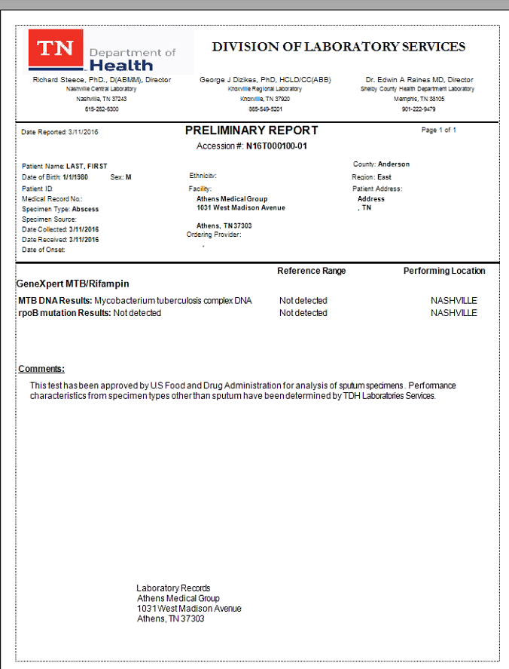

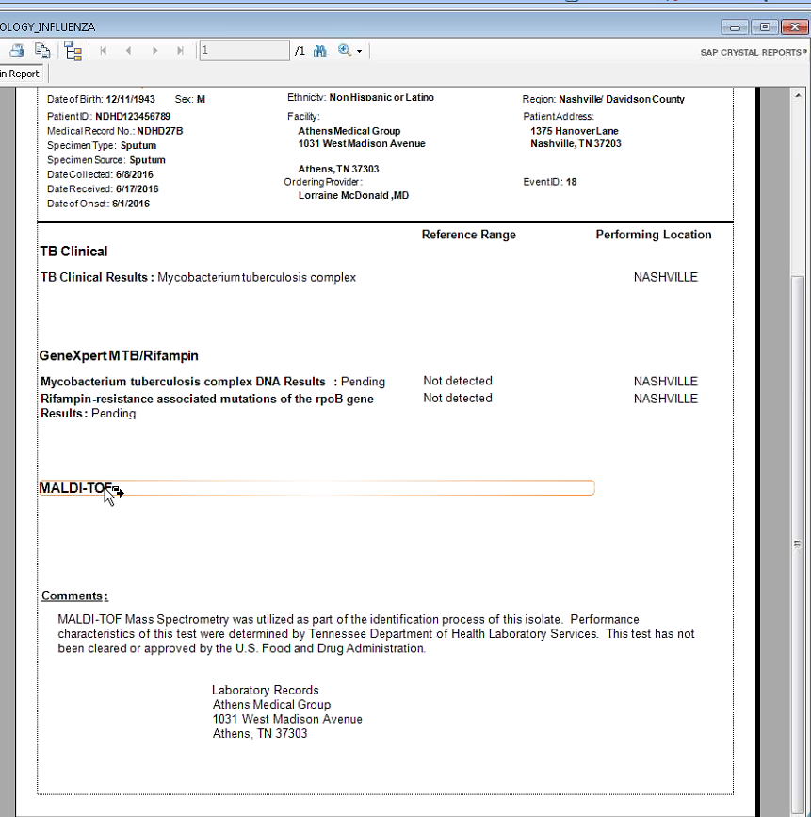

Communications Log Entry
Communications Log Entry – Not Applicable to Test Name?
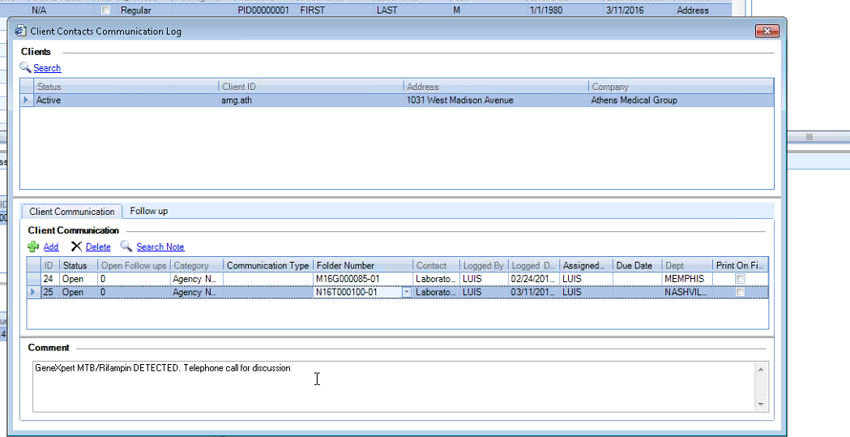

User Requirements Sign-Off
Tennessee Division of Laboratory Services
As Program Chief responsible for this test, I acknowledge that this document contains all functional user requirements, workflow processes, reporting and label printing requirements, and instrument interface specifications that are required to configure this test.

_______________________________________ __________________
Program Chief Date Accepted

Completed By: Date Completed:

Alerts: Alerts Management allows users to send alert messages to other users. A reminder, Administrative Alerts, will be displayed under the Alerts menu of those users who were defined as the recipients of the alert. The recipient user(s) can acknowledge the alert and complete it. This acknowledgment will be indicated in the Alerts Manager module for the sending user.
State Health Operations Center (SHOC)?
Reflex Tests: Associate additional test(s) with the original test. A button, OOS Alert, appears when this trigger is configured in the workflow and results are out-of-specification. When you click this button, a dialog box appears, in which you are given the option of executing the reflex or dismissing it. Identify and map triggers, sequence, and composition of what needs to be done in subsequent steps, e.g., partial retest.
Triggers: Triggers are defined in the context of a Test Workflow and can initiate actions, such as retests based on results that are out-of-specification, or other triggers, such as validations. If triggers are defined, the checkbox in the Test Workflow Diagram will be marked. Use the Sorter field to specify the order in which triggers launch other triggers.
Outsourcing: Outsourcing is typically decided either immediately after accessioning; or after tested internally, then sent it to CDC or Quest or LabCorp and record their results as a different test (indicating who actually performed the test).
Test Logic: Indicate any logic or action taken on results, such as: samples are run in duplicates, positives create a reflex test, or the sample must be retested in duplicates. Draw a work flow chart/algorithm indicating Repeat/Reflex triggers. These are typically required for Micro/Culture tests.

