HL7 Accessioning
- Open the Clinical Sample Login module.
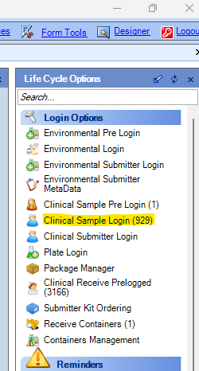
- Click on the HL7 Samples button.
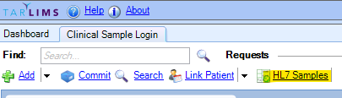

- In the pop-up, Scan the barcode in the blank barcode field.
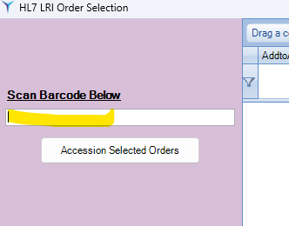
- StarLIMS will search for orders ending in the entered barcode value. Some orders are appended with “-1”, or other numbers. StarLIMS will still find these orders.
- If orders are found*¹, they will be displayed in the data grid.
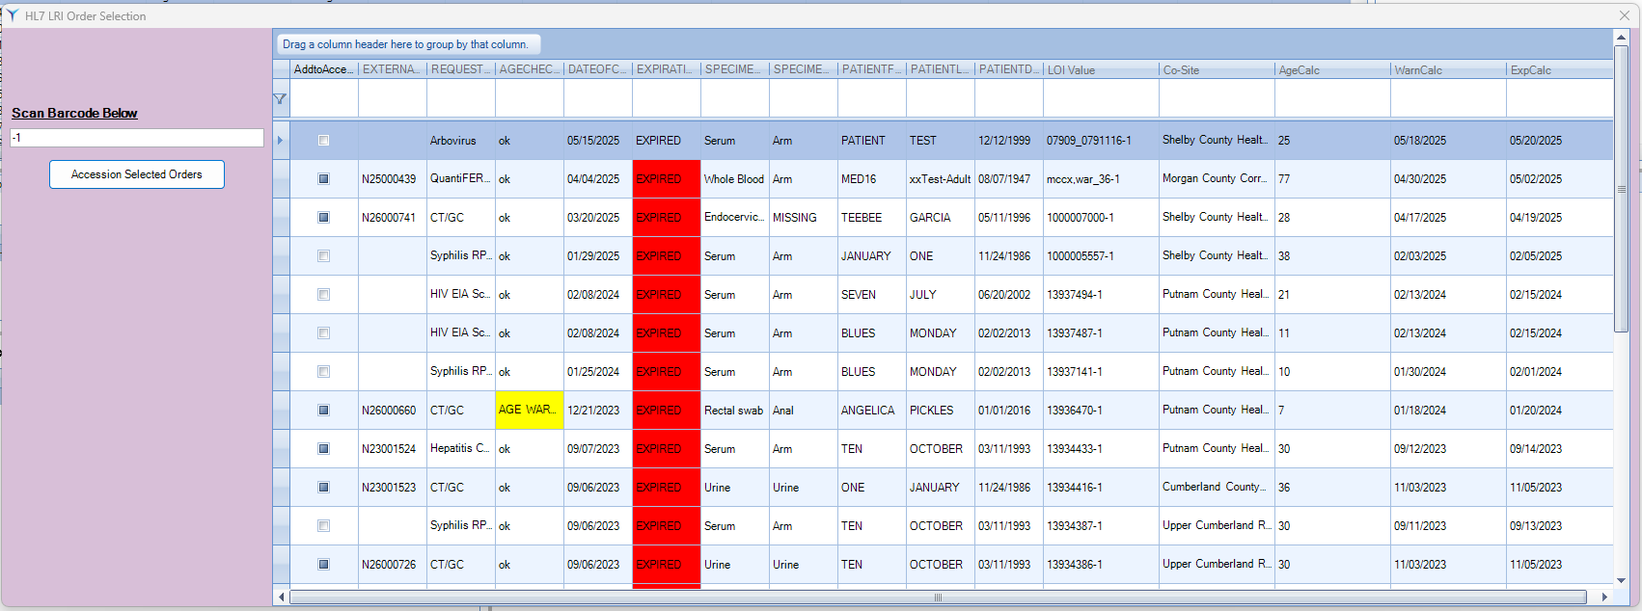

- Check the “Add to Accessioning List?” box for all orders you would like to receive*².
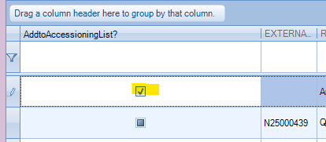
- Click the Accession Selected Orders button.
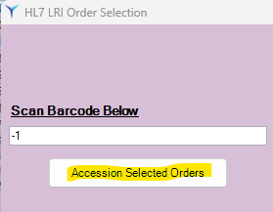
- If all expiration and age checks*³ are valid, StarLIMS will attempt to print labels*⁴.

Potential Issues
*1
- If no matching orders are found, the following pop-up will appear.
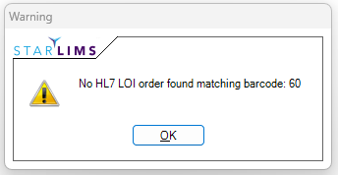
- Review the barcode to ensure the entire value was entered. If not, try to enter the value manually. You will have to press the ENTER or TAB key on the keyboard to refresh the data grid.
- If no values are returned, gather all data on the label and forward it the information to Lab.Informatics@TN.gov.

*2
- Orders with a blue box under the “Add to Accessioning List?” column indicates the order has already been accessioned. The accession number is listed to the right of this box. The order cannot be accessioned again.
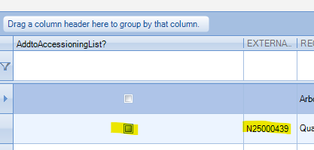

*3
- If there are issues with the age and/or expiration validation steps the following pop-ups will appear to alert the user.
  - Age:
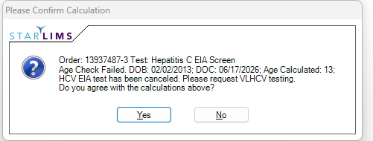
  - Expiration:
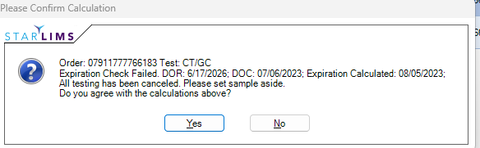
  - Both:
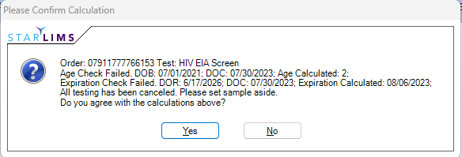

- Agreeing with the calculations will cancel the test(s).
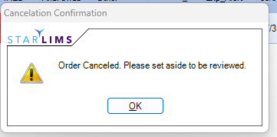
- Disagreeing with the calculations will accept the sample into the lab and require review in the Clinical Data Entry module.
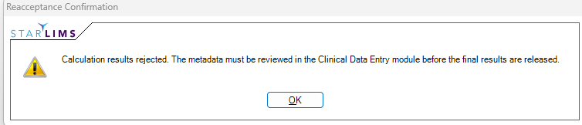

*4
- If not printer with the expected name is found, the following pop-up will appear.
- 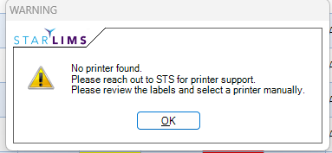
- Clicking the OK button will display the barcode PDF(s) and allow users to select the printer manually.
  - Select the Printer button.
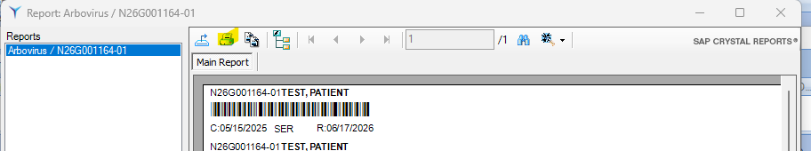
  - Update the selected printer in the Windows-based pop-up.
